HBD: Change in Seal sample
On 21/12/2017, Binh Duong PP Pack Making Joint Stock Company announced the change in Seal sample as follows:
- Seal sample
Old seal | New seal
: 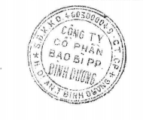 | 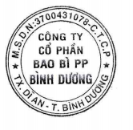
- Effective date: 19/12/2017

